**Lecture #3 Notes**

Assignment Operators

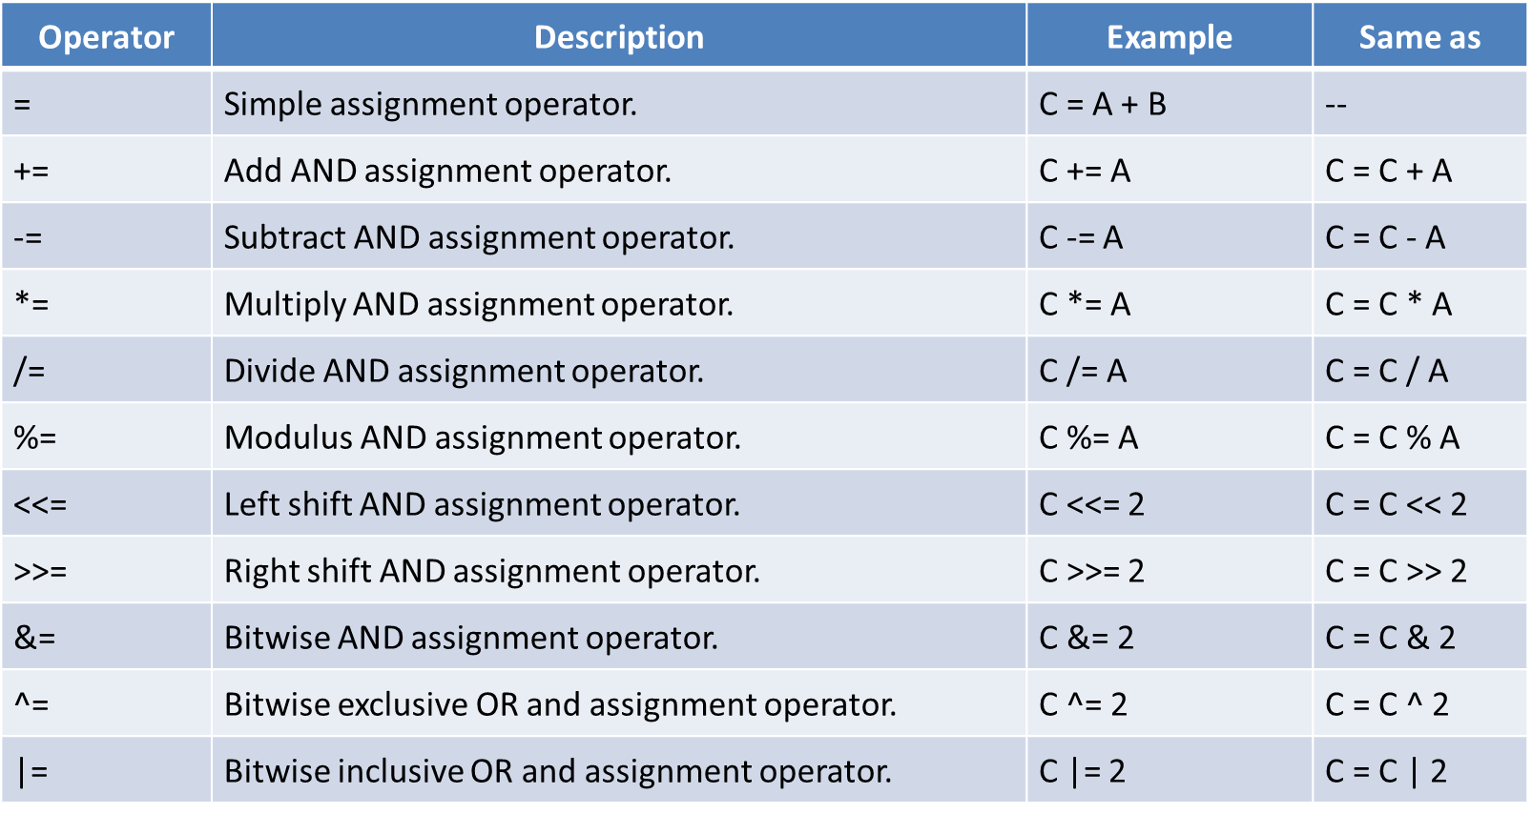

The case operation

If x >5 : x +3

If x < 5: 2x



**Convert from decimal to binary**

**Get**

**How to stop an infinite loop- Ctrl-C**

**Functions**

**Declaration**

**Definition**

**Call**

**Prototype -[return type] [function_name] (parameter types);**

**Int main();**

[return type name] [function_name](parameter type names) {}

**Prototype needed for compiler**

**Functions can make changes in memory**

**Can you do this**

**Int a= 1**

**Int b =2**

**Int main();**

**Int a =1**

**Int b = 2**

**Int sum sum(int a, int b)**

**Return a+ b**

**Yes, but it makes no sense**

**Initializaing Variables**

**Gotta init everything**

**And declare it too**

**Cant init var in loop declaration**

**Arrays**

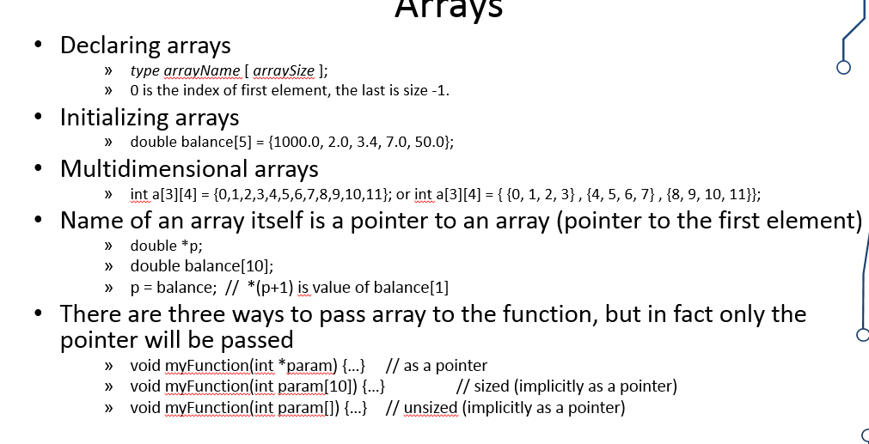**Try to understand 3.3**